Introduction to company law (RELATIVE CLAUSES, MODALS)
A company (US: corporation) is a business association which has the character of a legal person, distinct from its officers and shareholders. This is significant, as it allows the company to own property in its own name, continue perpetually despite changes in ownership, and insulate the owners against personal liability. However, in some instances, for example when the company is used to perpetrate fraud, the court may 'lift (US: pierce) the corporate veil' and subject the shareholders to personal liability.
By contrast, a partnership is a business association which is not considered to be a legal entity but, rather, merely an association of owners. However, in order to avoid impractical results, such as the partnership being precluded from owning property in its own name, certain rules of partnership law treat a partnership as if it were a legal entity. Nonetheless, partners are not insulated against personal liability, and the partnership may cease to exist upon a change in ownership, for example, when one of the partners dies.
A company is formed upon the issuance of a certificate of incorporation (in the US generally no official certificate is issued; companies are formed upon the filing of the articles/certificate of incorporation) by the appropriate governmental authority. A certificate of incorporation is issued upon the filing of the constitutional documents of the company, together with statutory forms and the payment of a filing fee. The 'constitution' of a company consists of two documents. One, the memorandum of association (US: articles of incorporation or certificate of incorporation), states the objects of the company and the details of its authorised capital, otherwise known as the nominal capital. The second document, the articles of association (US: bylaws), contains provisions for the internal management of the company, the board of directors, corporate contracts and loans. The management of a company is carried out by its officers, who include a director, manager and/or company secretary.

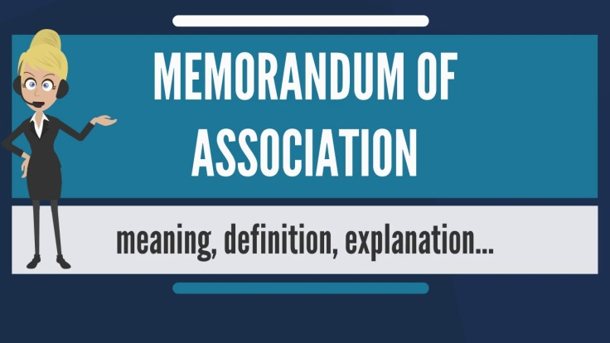

shareholder- (US stockholder)
A person who owns shares in a company and therefore gets part of the company’s profits and the right to vote on how the company is controlled
legal person – legal entity- pravno lice

officer- a person who has a responsible position of authority in an organization- državni činovnik, službenik Synonyms: official, executive, agent, representative

perpetually – always or very often, continually, repeatedly

lifting/piercing the corporate veil – a legal decision to treat the rights or duties of a corporation as the rights or liabilities of its shareholders – probijanje pravne ličnosti

to subject – to subjugate – to cause or force to undergo or endure something unpleasant – podvrgnuti, pozvati na

to preclude from – to prevent from

to cease – to stop from

issuance – the action of formally making something known

A Certificate of Incorporation is a legal document / license relating to the formation of a company or corporation.

constitution – the act of establishing, making or setting up

A Certificate of Incorporation is a legal document / license relating to the formation of a company or corporation.

constitution – the act of establishing, making or setting up

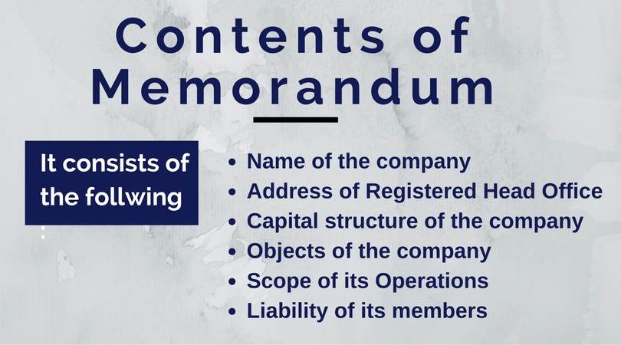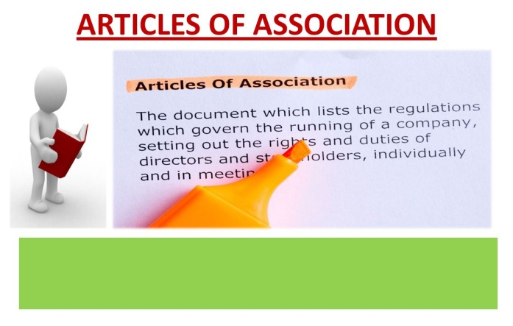

INTRODUCTION TO COMPANY LAW*KAO TEST*

1 For the British English term company, they use ___ in the USA.
A collective
B corporate
C corporative
D corporation

2 A company is a business association which has the character of a legal ___ .
A person
B personality
C perspective
D partner

3 However, in some instances, the shareholders may be ___ to personal liability.
A subjected
B received
C reciprocal
D objection

4 A company is formed upon the issuance of a certificate of ___ .
A corporate
B incorporated
C incorporation
D inspection

5 A certificate of incorporation is issued by the appropriate ___ authority.
A government
B governor
C governing
D governmental

6 This means that in some instances the court may 'lift (US: pierce) the corporate ___ '.
A verification
B vendors
C veil
D vest

7 This happens for example when the company is used to ___ fraud.
A pretend
B present
C perpetrate
D perfected

8 A partnership is also a kind of a business ___ .
A association
B associate
C aspects
D aspiration

9 A partnership is rather nothing more
than an association of ___ .
A owners
B owed
C owing to
D ownership

10 The 'constitution' of a company consists of two ___ .
A delegates
B documents
C documentaries
D destination

